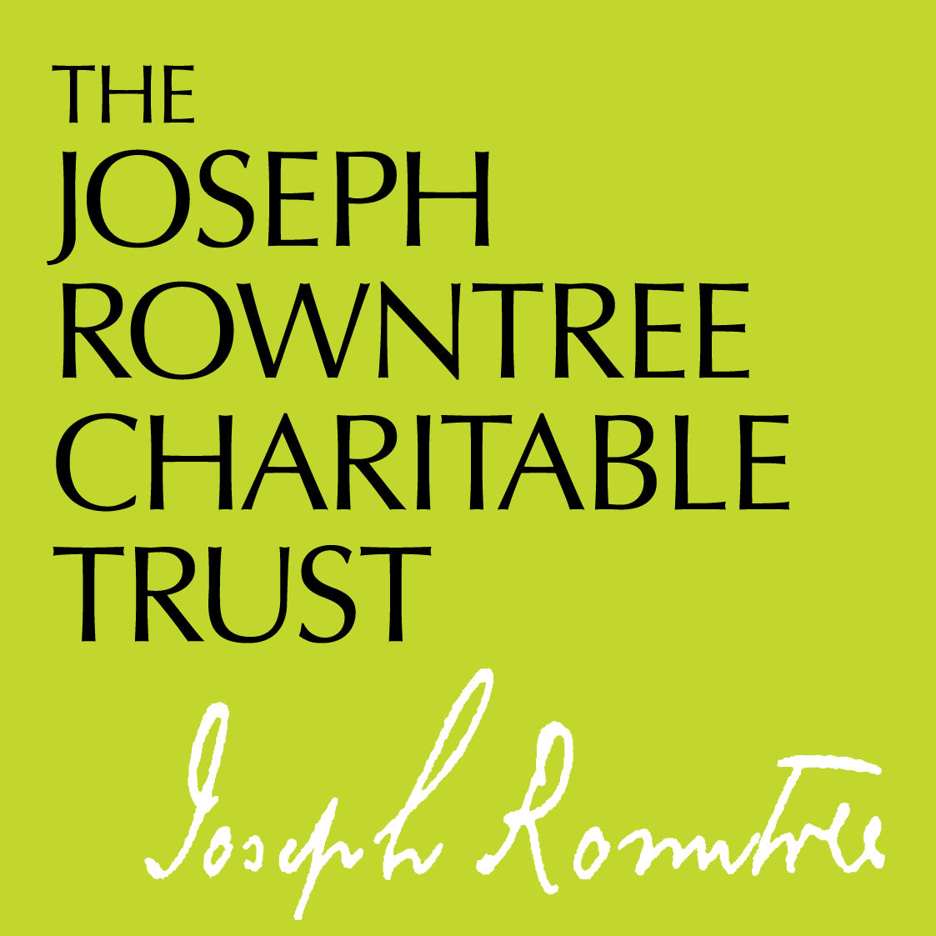

Early Closing Report

Introduction
If you apply for further funding from the Trust before your current grant comes to an end you will need to submit an early closing report on that grant. alongside your new application. This enables us to consider the new request in the context of the work undertaken over the course of the current grant so far. We understand that the report will necessarily only be partial, as the full term is not complete, and you are welcome to indicate where future key activities are planned.

Please download this document and answer all the questions. The finished document should be no longer than 6 sides of A4. When you have finalised your report please save it as a PDF and upload it with your other application documents through your online portal.

Grant information
Applicant’s name: please enter
Organisation name: please enter
Date of early closing report: please enter
End date of current grant: please enter

Reviewing the work undertaken
- Have the original objectives of the work supported by JRCT (as set out in your application) changed during the grant period? If so, how?
- Which of the objectives have been most successfully achieved? In what way were these areas particularly successful? Why?
- Which of the objectives have been least successfully achieved in your view? In what way were these areas not successful? Why?

Significance and learning
- In your view, what impact has the work funded by this grant had? Is there any evidence to support this?
- In what ways do you think that the impact achieved by the work contributes to JRCT’s policy priorities? Do you have any comments on the ongoing relevance (or otherwise) of the Trust’s priorities?
- Are there any lessons from the work which you think may be transferable to other social change initiatives (in addition to the necessity of funding)?
- Was any evaluation carried out of the work (internally and/or independently)?

Plans and outlook for the future
- Is this area of work continuing? If so, have you secured new funding for it?
- Have you spent all the funds we gave you? (If you are carrying forward a balance, please explain your plans and timeframe for spending these funds.)
- Has the organisation as a whole changed significantly during the period of this grant – in terms of staff, location, strategy, finance, funding base, etc.?

Relationship with JRCT
- Have you found the relationship with the Trust satisfactory? What has worked well? What could have been better?

Other comments
- Are there any other comments you would like to make?

February 2020

